**CASCADING STYLE SHEET**

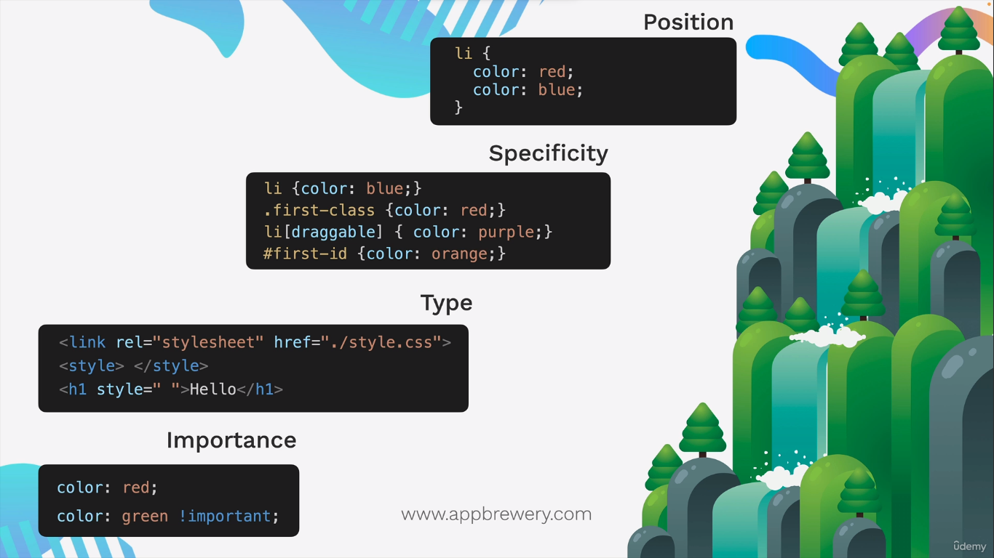This is how the rules applied when you integrate the css with html

**2. where ABSOLUTE POSITION used in real time**

Overlays and Modals: Absolute positioning is often used to create overlays, modals, or pop-up dialogs on webpages. These elements can appear on top of the regular content and be positioned precisely using absolute positioning. This is common in things like login forms, image galleries, or informational pop-ups.

Tooltips: Tooltips that display additional information when hovering over or clicking on an element can be created using absolute positioning. The tooltip is positioned near the element it relates to.

Navigation Menus: In some cases, navigation menus, especially dropdown menus, may use absolute positioning to ensure they appear exactly where intended, often relative to a navigation bar.

Scroll-Triggered Elements: Elements that become fixed or sticky when scrolling to a certain point on the page often use absolute positioning. This allows the element to stay in a fixed position within the viewport.

Image Galleries and Sliders: Creating image galleries or sliders that display images in a specific location on the page can involve absolute positioning. This ensures that the images are displayed where and how the designer intended.

Custom Headers and Footers: Designers sometimes use absolute positioning to create custom headers or footers that don't adhere to the typical flow of the document. These headers or footers may have unique designs that require precise placement.

Interactive Elements: Absolute positioning is used for interactive elements that need to follow the cursor or respond to user interactions while remaining in a specific location.

Z-Index Control: When you have overlapping elements, absolute positioning allows you to control their stacking order (z-index) to determine which one appears in front of the other.

Graphs and Charts: In data visualization, elements like labels or data points on graphs and charts can be positioned absolutely for clarity and precision.

Custom Widgets: When creating custom widgets or user interface elements that don't conform to standard document flow, absolute positioning can be used to place and control these elements accurately.

**3. Block and inline elements**

**Block-Level Elements:**

**<address>:** Represents contact information for the author or owner of a document.

<**article**>: Defines a self-contained composition in a document, such as a news article.

<**aside**>: Represents content that is tangentially related to the content around it.

<**blockquote**>: Indicates that the enclosed text is a longer quotation from another source.

<**div**>: A generic container for flow content that doesn't inherently represent anything.

<**dl**>: Defines a description list, typically used with <dt> (term) and <dd> (description) elements.

<**fieldset**>: Groups form controls and labels together for better organization.

<**figcaption**>: Provides a caption or description for a <figure> element.

<**figure**>: Represents any content that is referenced from the main content, such as images and illustrations.

<**footer**>: Represents the footer of a section or page.

<**form**>: Defines an HTML form for user input.

**<h1>, <h2>, <h3>, <h4>, <h5>, <h6>:** Headings

<**header**>: Represents the header of a section or page.

<**hr>:** Represents a thematic break or horizontal rule.

**<li>:** Represents a list item within ordered (<ol>) or unordered (<ul>) lists.

<**main**>: Represents the main content of the document, excluding headers, footers, and sidebars.

<**nav**>: Represents a section of navigation links.

**<ol>:** Defines an ordered (numbered) list.

**<p>:** Represents a paragraph of text.

<**pre>:** Preformatted text, which preserves whitespace and line breaks.

**<section>:** Represents a standalone section of content within a document.

**<table>:** Defines a table.

**<ul>:** Defines an unordered (bulleted) list.

**Inline-Level Elements:**

**<a>:** Represents a hyperlink.

**<abbr>:** Represents an abbreviation or acronym, with an optional full form.

**<b>:** Represents text in a bold font.

**<br>:** Represents a line break or forced newline within text.

**<cite>:** Represents the title of a creative work or reference.

<**code**>: Represents a fragment of code.

<**em**>: Represents text in emphasized or italicized form.

**<i>:** Represents text in an alternate voice or mood, such as italicized text.

<**img**>: Represents an image.

**<q>:** Represents a short inline quotation.

**<s>:** Represents text that is no longer accurate or relevant (strikethrough).

**<span>:** A generic inline container for styling and scripting.

<**strong**>: Represents strong importance or emphasis.

<**sub**>: Represents subscript text.

<**sup**>: Represents superscript text.

**<u>:** Represents text with an underline.

**<var>:** Represents a variable in programming or mathematics.